This Is the Title of Your Manuscript
(22-point font, Times New Roman [TNR], bold, small caps, centered)
Name of first author, Name of University; Name of second author, Name of Company or Institution (9-point, Times New Roman, centered)
(one blank line, 10-point font)

Abstract (14-point, Times New Roman, left justified)
(unless otherwise specified, all text is 10-point, full-justified)
(one blank line, 10-point font)
The effort to reduce CO₂ emissions has been a challenge for automakers to meet the technical regulations for the Worldwide Harmonized Light Duty Test Procedure (WLTP).
------------------------------------------------------------
(do not use tabs anywhere in the document)
(indent each full paragraph 1/8" as shown here)

(do not use personal pronouns: “we” “our” etc.)
------------------------------------------------------------
In this present study, the authors focused on the friction factor in differential bearings, which are responsible for a great amount of energy loss due to friction. Bearing manufacturer Schaeffler proposed replacing the tapered roller bearing (TRB) with the tapered ball bearing (TBB), thereby allowing a 50% reduction in friction and reducing CO₂ emissions by 1.5%. To understand the increase in differential efficiency by replacing the TRB bearing with the TBB bearing, and using the friction calculation of rolling bearings, a computer simulation of the sliding frictional moment (M_{sfm}) was performed; the authors found the TBB-type bearings had a linear behavior with a progressive increase in friction as a function of rotation, with a significant reduction in friction, when compared with the TRB-type bearing. The authors concluded that TBB-type bearings were more energy efficient than TBR bearings under the same operating conditions, contributing to increased mechanical efficiency and reduced CO₂ emissions.
(one blank line, 10-point font)
Introduction (all headers are 14-point, TNR)
(one blank line, 10-point font)
Since the time when designers improved the use of the wheel by adding bearings, there was concern over wheel-axle friction. Before the advent of the steam engine, this loss of energy reduced the capacity of human- or animal-powered vehicles and caused a reduction in performance. This resistance to movement was the objective of studies carried out by ancient civilizations. Research has shown that rudimentary bearings were manufactured as early as 900 BC to 400 AD by Romans, Celts, Greeks, and the Chinese. Archaeological research from the end of the 19th century found an ancient ball bearing in Lake Nemi, located 18 miles from Rome (Dowson & Hamrock, 1981; Jacobson, 2011). Apparently, nothing was improved during the Middle Ages; however, the Renaissance genius Leonardo Da Vinci (1894) carried out studies in the field of tribology, establishing the first laws on the interaction of surfaces in relative motion in 1493 (Hutchings, 2016) including the results of his studies in the Codex Atlanticus (Da Vinci, 1894). In his work, he concluded that the sliding friction coefficient was constant and equal to 1/4 for all materials (Dowson & Hamrock, 1981). His research served as a reference for Amonton’s studies (Persson, Sivebæk, Samoilov, Zhao, Volokitin, & Zhang, 2008) on tribology. With the advent of the Industrial Revolution, ball bearings came to take their place in the manufacture of machinery and equipment; and from the beginning of the 20th century, ball bearings were applied to automobiles and other vehicles (Dowson & Hamrock, 1981), playing an important role, because, in addition to reducing the friction of the rotating motion of the wheels, they are an integral part of the suspension and support the weight of the vehicle (Park, Choi, & Kim, 2013). The model designed by Da Vinci was widely used until 1907, when Sven Wingquist patented the self-aligning bearing, whose main benefit was to support greater loads without reducing its useful life, even with limited shaft misalignment (Jacobson, 2011).
(one blank line, 10-point font)
Friction and Losses
(one blank line, 10-point font)
Concerns related to loss of energy by friction are centuries old. Despite the introduction of electric and hybrid cars, most of the fleets made up of such vehicles continue to use fossil-fuel energy sources. These vehicles operate both in the diesel cycle (Institute, 2017; Scoltock, 2010) and in the Otto cycle (Poulton, 1994) and have a common feature: low energy efficiency. Only 12% of the energy available in the fuel is made available to the traction wheels, of which 15% is lost due to friction (Comfort, 2003; Nakasa, 1995; Priest & Taylor, 2000). Only two factors must be considered responsible for fuel consumption.
(one blank line, 10-point font)
(only use periods in bullet lists after complete sentences)
- Vehicle load: the work or energy required to move the vehicle and the functioning of its accessories
- Energy efficiency of the engine plus transmission
(one blank line, 10-point font)
In view of the ever-increasing number of vehicles in use, reducing fuel consumption becomes a priority (Ross, 1997). On this topic, the search for improving energy efficiency is not only of economic importance, but also environmental in the face of global warming (Mickūnaitis, Pikūnas, & Mackoit, 2007). The effort to reduce CO₂ emissions in internal combustion vehicles, whether they are trucks, buses or automobiles, has been a challenge for automakers (Allmaier, Sander, & Reich, 2013; Kitamura, 2003). The environmental issue is being treated as a global issue and, in 2014, the United Nations Economic Commission for Europe (UNECE) established technical regulations for the Light Services Test Procedure (WLTP) with a global scope (Tsokolis, Tsiakmakis, Dimaratos, Fontaras, Pistikopoulos, Ciuffo, & Samaras, 2016; Mickūnaitis et al., 2007). With the use of new technologies, Holmberg and his colleagues (Holmberg, Andersson, Nylund, Mäkelä, & Erdemir, 2014) pointed to an expectation of savings in diesel consumption in trucks on the order of 75 billion liters and a reduction in emissions of 200 million tons of CO₂ by 2022, totaling world-wide annual savings of $127 billion US dollars. The same authors also estimate that frictional energy losses in light vehicles are between 25% and 30%, an unnecessary emission of 25-30g of CO₂ / km for a passenger car with a 2-liter engine (Ligier & Noel, 2015).
(one blank line, 10-point font)
With a focus on environmental and financial issues, the search for the reduction of internal friction in internal combustion engine vehicles has become a worldwide trend. The study of friction in moving parts of engines, transmission systems, gearboxes, differentials, and systems lubrication and lubricants are the subject of research in several works (Knauder, Allmaier, Sander, & Sams, 2020; Wong & Tung, 2016; Yonggang, Xu, Jin, Braham, & Yuanzhong, 2020). Although there are several points in a vehicle where energy is dissipated in the form of friction (Comfort, 2003; Nakasa, 1995; Priest & Taylor, 2000; Tung & Mcmillan, 2004), the focus of this current study was on the bearings of a transmission differential.
(one blank line, 10-point font)
The Differential Gearbox
(one blank line, 10-point font)
The differential is a highly complex gearbox that compensates for the differences in rotation of the drive wheels, allowing them to turn at different speeds in a curve, where the distance traveled by the inner wheel is shorter than the distance traveled by the outer wheel. For full-drive vehicles, it acts similarly between the front and rear drive axles (Toke, Kurkure, Waghumbare, & Jejurkar, 2018). Excluding special cases, the concept of bevel gears is preferred for axle and wheel differentials, as these gears act as scale dashes establishing the torque balance between the right and left wheels. (Antoni, 2014; Ribbens, Heisler, Blundell, Harty, Brown, Serpento, & Davies, 2009). In association with the transmission, the differential is responsible for the greatest amount of energy loss due to friction (Sharma & Goyal, 2019; Tsokolis et al., 2016). Even though the greatest friction loss within a differential box occurs in its gears (Patil, Shevade, Gund, Utage, Patane, & Patel, 2017), this fact is largely minimized using lubricants (Tung & Mcmillan, 2004; Wong & Tung, 2016); the input and output torque of the entire differential system is supported by bearings, which also contribute to friction loss (Holmberg et al., 2014).

Although the gears are mainly responsible for the loss of energy due to friction, in a research study carried out by the German-based bearing manufacturer Schaeffler (2014) and published by SAE International (Plank & Schwarzenthal, 2010), the replacement of the tapered roller bearing (TRB) by the tapered ball bearing (TBB) type could lead to a 50% reduction in the differential’s internal friction. The replacement could also provide a 1.5% reduction in the vehicle’s total CO₂ emissions; however, the manufacturer does not specify the vehicle model used in the software simulation (Niederbacher, 2016). This statement was evaluated by Pilot Systems International, which identifies in its AWD component analysis (Niederbacher, 2016) report, a considerable reduction in friction in the differential, due to the replacement of TRB-type bearings with the TBB type. Although the result of this substitution is positive, other manufacturers claim that there are alternatives available at lower costs (Niederbacher, 2016). To understand the increase in differential efficiency by replacing the TRB bearing with the TBB bearing, a brief review of the physical phenomena related to bearings is necessary. These concepts are used for the elaboration of several software packages for systems performance evaluation, based on bearings and gears (Geonea, Dumitru, & Dumitru, 2017; Gynning Olofsson, 2017; Otter, Dempsey, & Schlegel, 2000). Taking as a reference the model designed by SKF (2014) to calculate the frictional moment, it is possible to observe that it has numerous variables for its determination. Bearing friction is not constant and depends on certain tribological phenomena that occur in the lubricating film between the rolling elements, the raceways, and the cages (Khonsari & Booser, 2017; Yonggang et al., 2020).
(one blank line, 10-point font)
The Total Frictional Moment
(one blank line, 10-point font)
To calculate the total frictional moment of a bearing, the following variables were adopted.
- The frictional moment and the possible effects of high-speed exhaustion
- The moment of sliding friction and its effect on the integrity of lubrication
- The frictional moment of the sealing system
- The moment of friction of drag losses
(one blank line, 10-point font)
Based on this, the equation that best approximates the real behavior of a bearing is represented by Equation 1.
(one blank line, 10-point font)
(equations are numbered and right-justified)
$M=M_{rfm}+M_{sfm}+M_{fms}+M_{fmd}$ (1)
(one blank line, 10-point font)
where,
M = moment of total friction – [Nm]
M_{rfm} = rolling frictional moment – [Nm]
M_{sfm} = sliding frictional moment – [Nm]
M_{fms} = friction moment of the seals – [Nm]
M_{fmd} = frictional moment of drag losses, agitation – [Nm]
(one blank line, 10-point font)
Although this equation is relatively simple, its variables result from complex calculations, according to the type of bearing analyzed, lubrication, load, temperature of the lubricating fluid, rotation of the bearing, viscosity of the lubricant, and its drag factor. The model for calculating the frictional moment (SKF, 2014) provides a tutorial on how to calculate the total frictional moment. SKF subsidiary Schaeffler International (2014) makes available and online, free of charge, calculation module for the detailed friction calculation of rolling bearings that go by the name of Bearinx (Schaeffler, 2014). This software allows for the calculation of all the friction forces of the bearing’s surfaces, considering rolling friction as well as sliding friction in the solid body friction, mixed friction and fluid friction ranges, losses in the load-free zone, splashing losses from the lubricant, and seal friction components.

To assess the variation in friction in the differential resulting from the replacement of TRB-type bearings by TBB-type bearings (Niederbacher, 2016; Plank & Schwarzenthal, 2010), the Bearinx computational tool was used, allowing analysis while considering the behavior conditions of non-linear elastic bending of the bearings, elasticity of the shafts, preload or operating clearance of the bearing, profile of rollers and raceways, as well as oscillation, in ball bearings, loading correlated with the change in the contact angle, actual pressure of contact, and taking into account the inclined position and profile of the rolling element, influence of notches (reliefs) in contact regions, influence of lubrication conditions, contamination, and real contact pressure on the fatigue resistance. In the computational analysis of the TRB and TBB bearings, only the sliding frictional moment (Msfm) defined by Equation 2 was considered.
(one blank line, 10-point font)
$M_{sfm}=G_{sl+}μ_{sfc}$ (2)
(one blank line, 10-point font)
where,
M_{sfm} = sliding frictional moment [Nm]
G_{sl} = variable that, depending on the type of bearing,
the radial load Fr [N] and the axial load Fa [N]
M_{sfc} = sliding friction coefficient
(one blank line, 10-point font)
For computer simulations of both the TBB-type and TRB-type bearings, the defined contour variables were:
- Temperature: 50⁰C
- Axial load (frictional torque): 1000N, 2000N and 3000N
- Radial load: 0N
- TRB bearing rotation: 50 rpm, 100 rpm, 250 rpm, and 500 rpm
(one blank line, 10-point font)
Table 1 shows the results obtained with the aid of the computational tool.
(one blank line, 10-point font)
Table 1. Friction torque (Newton meter) applied to the TRB-type bearing.
(captions are 9-point, left-justified; use italics and periods as shown)
rpm | 50 | 100 | 250 | 500
TRB: 1000N | 0.166 | 0.157 | 0.226 | 0.352
TRB: 2000N | 0.269 | 0.218 | 0.266 | 0.415
TRB: 3000N | 0.381 | 0.271 | 0.293 | 0.453
(one blank line, 10-point font)
These results show a significant increase in the torque at low speeds (50 rpm) and at high speeds (500 rpm). Figure 1 shows, however, that a) the system was more efficient at 100 rpm and b) that the TBB-type bearing has a linear behavior with a progressive increase in friction as a function of rotation.
(one blank line, 10-point font)
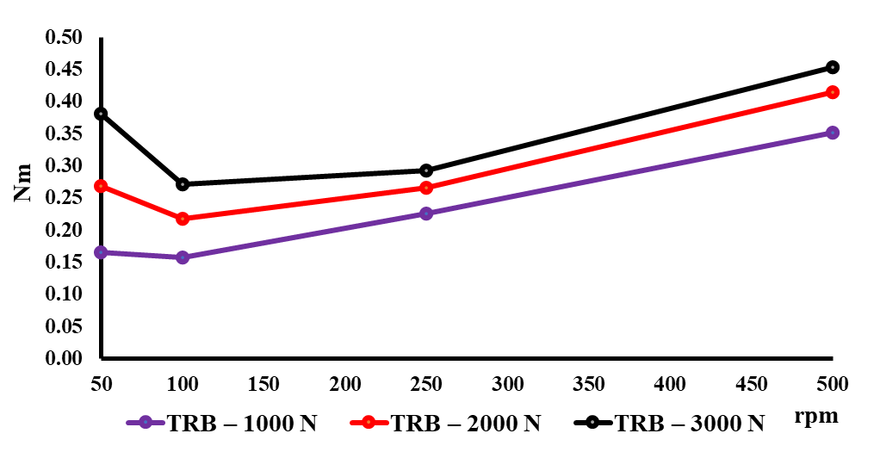

(a) Simulation of the TRB bearing.
(one blank line, 10-point font)
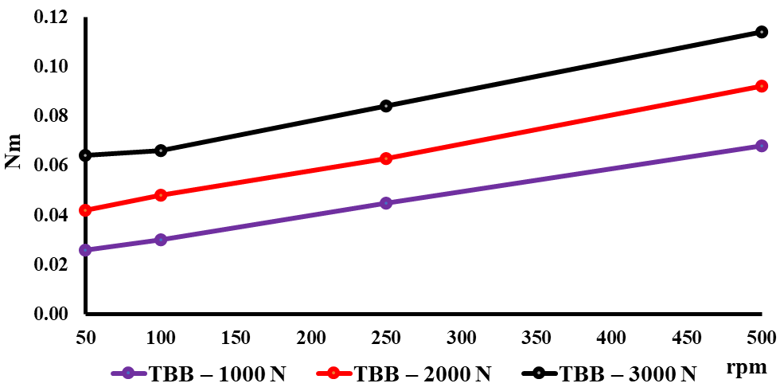

(b) Simulation of the TBB bearing.
(one blank line, 10-point font)
Figure 1. Friction torque simulations.
(Figures with multiple parts/images should be formatted as shown above. Each image has its own sub-caption, 9-point font, NOT italicized, and is center-justified. There must also be a main caption for the overall figure; 9-point font, left-justified, only the word “Figure” and the number ARE italicized, as shown.)
(one blank line, 10-point font)
Table 2 shows the values obtained for the TBB bearing under the same conditions adopted for the TRB bearing.
(one blank line, 10-point font)
Table 2. Friction torque (in Newton meters) applied to the TBB-type bearing.
rpm | 50 | 100 | 250 | 500
TBB: 1000N | 0.026 | 0.030 | 0.045 | 0.068
TBB: 2000N | 0.042 | 0.048 | 0.063 | 0.084
TBB: 3000N | 0.064 | 0.066 | 0.084 | 0.114
(one blank line, 10-point font)
Table 3 shows a relative comparison between the two simulations.
(one blank line, 10-point font)
Table 3. Friction reduction (%) between TRB and TBB bearings.
rpm | 1000N | 2000N | 3000N
50 | 15.66 | 15.61 | 16.84
100 | 19.11 | 22.02 | 24.54
250 | 19.91 | 23.68 | 28.67
500 | 19.32 | 22.17 | 25.17
(one blank line, 10-point font)
Figure 2 indicates that, for all computer simulations, the TBB bearing showed a significant reduction in friction when compared to the TRB bearing.
(one blank line, 10-point font)

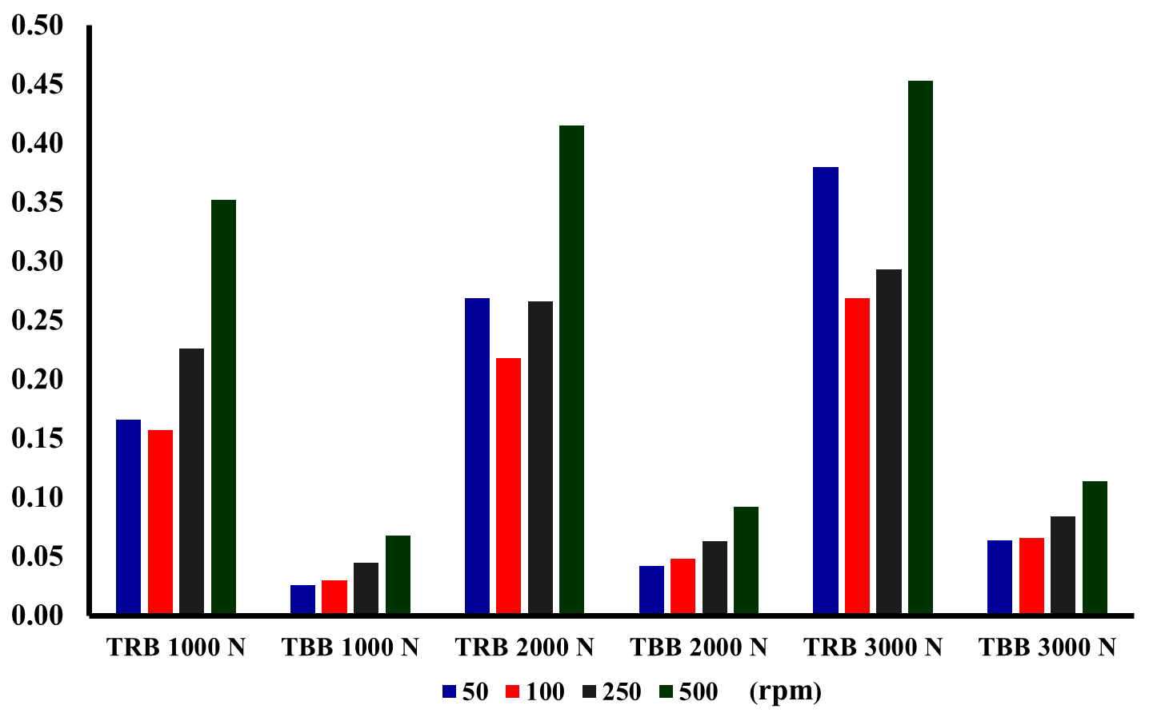

Figure 2. Comparison of friction reduction between TRB and TBB bearings.

Figure 3 shows the performance differences between TRB and TBB bearings under the same operating conditions.
(one blank line, 10-point font)
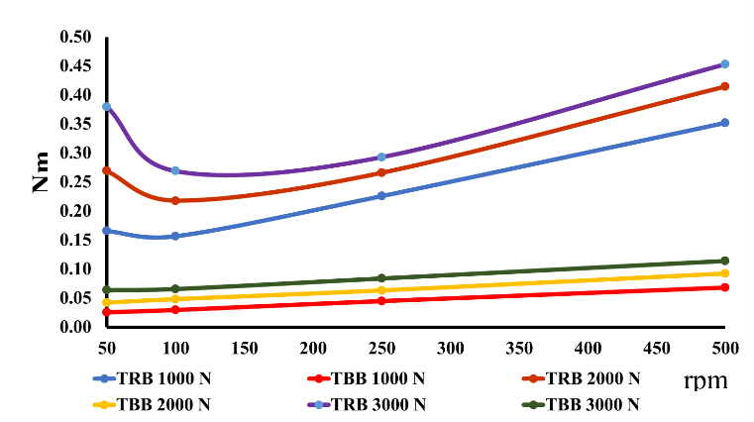

Figure 3. Graphical comparison of friction reduction (%) between TRB and TBB bearings.
(one blank line, 10-point font)
Software Validation
(one blank line, 10-point font)
Before the existence of computers and software for analysis, bearing manufacturers used empirical calculation models that enabled estimations based on the type of bearing, the supported load, speed, and the viscosity of the lubricant. Using equations based on the results of laboratory bench tests (Dudziak & Krome, 2015), the Palmgren equations (Lundberg & Palmgren, 1947) were used most often (which served as the basis for ISO 15312). A bench test was made up of a physical model, where the bearing was experimentally subjected to a test in order to determine the friction torque. This testing device was equipped with sensors that could capture certain variables from the behavior of a specific bearing, obtaining its friction torque curve once it was subjected to a progressive series of radial loads. In contrast to bench tests, there is an analytical method that uses a mechanical and tribological model of the bearing; the mechanical model is used to map the application of forces, load distribution and other variables. The tribological model associated with the mechanical model describes the behavior of different tribological phenomena (Geonea et al., 2017). The analytical method, when transformed into an algorithm, allows the in-silico study of the behavior of the bearings, and the validation of the software is performed with the help of other similar computer packages, bench tests, and models, including frictional torque, kinematics, and cage loads (Schaeffler, 2014). Unfortunately, further details about this validation process performed by manufacturers are difficult to access, as they are deemed industrial secrets.
(one blank line, 10-point font)
Conclusions
(one blank line, 10-point font)
From this current study, the authors demonstrated that TBB-type bearings are more energy efficient than TBR bearings under the same operating conditions. Considering that the generation of CO₂ is directly related to fuel consumption, which is subject to the mechanical efficiency of the vehicle’s subsystems, the replacement of TRB bearings by TBB bearings in the differential could result in a reduction of emissions. Within this context, it is possible that the extension of this reasoning to all other subsystems of a motor vehicle will result in emission rates and energy efficiency in line with current environmental standards. The results encourage the creation of “in silico” tools from physical models that can contribute to the solution of economic and environmental challenges.
(one blank line, 10-point font)
References
(Use APA formatting for references. Begin each reference with the first author’s last name, followed by the author’s initials. Separate all authors’ names with a comma. Indent subsequent lines 1/4". Refer to the Formatting Guide for References on our websites for additional help.)
(one blank line, 10-point font)
Allmaier, H., Sander, D. E., & Reich, F. M. (2013). Simulating friction power losses in automotive journal bearings. Procedia Engineering, 68, 49-55.
Antoni, G. (2014). On the Mechanical Friction Losses Occurring in Automotive Differential Gearboxes. The Scientific World Journal, 2014, 523281. doi:10.1155/2014/523281
Comfort, A. (2003). An introduction to heavy-duty diesel engine frictional losses and lubricant properties affecting fuel economy-Part I (No. 2003-01-3225). SAE Technical Paper.
Da Vinci, L. (1894). Codex Atlanticus. Biblioteca Ambrosiana, 26(1). Milan.
Dimaratos, A., Tsokolis, D., Fontaras, G., Tsiakmakis, S., Ciuffo, B., & Samaras, Z. (2016). Comparative evaluation of the effect of various technologies on light-duty vehicle CO₂ emissions over NEDC and WLTP. Transportation Research Procedia, 14, 3169-3178.
Dowson, D., & Hamrock, B. J. (1981). History of ball bearings. Retrieved from https://ntrs.nasa.gov/citations/19810009866
Dudziak, M., & Krome, A. (2015, July). TCO optimization during design phase-assessment of bearing concepts by calculation and simulation. In IOP Conference Series: Materials Science and Engineering, 90(1), 012080. IOP Publishing
Geonea, I., Dumitru, N., & Dumitru, I. (2017). Experimental and theoretical study of friction torque from radial ball bearings. In IOP Conference Series Materials Science and Engineering, 252(1), 012048. IOP Publishing.
Gynning-Olofsson, T. (2017). Main bearing support investigation-A comparison of wear and friction losses for different design proposals (Master’s thesis). Chalmers Open Digital Repository. https://odr.chalmers.se/handle/20.500.12380/248566
Holmberg, K., Andersson, P., Nylund, N.-O., Mäkelä, K., & Erdemir, A. (2014). Global energy consumption due to friction in trucks and buses. Tribology International, 78, 94-114.
Hutchings, I. M. (2016). Leonardo da Vinci’s studies of friction. Wear, 360, 51-66.
Institute, T. (2017). Rudolf Diesel. Retrieved from http://www.tesla-institute.com/index.php/electrical-engineering-articles/431-rudolf-diesel
Jacobson, B. (2011). History of rolling bearings. Tribology online, 6(3), 155-159.
Khonsari, M. M., & Booser, E. R. (2017). Applied tribology: bearing design and lubrication. John Wiley & Sons.
Kitamura, M. (2003). Technical Trend of Bearing for Automotive Drive Train. Koyo Engineering Journal (164), 19-23.
Knauder, C., Allmaier, H., Sander, D. E., & Sams, T. (2020). Investigations of the Friction Losses of Different Engine Concepts: Part 3: Friction Reduction Potentials and Risk Assessment at the Sub-Assembly Level. Lubricants, 8(4), 39.
Ligier, J.-L., & Noel, B. (2015). Friction reduction and reliability for engines bearings. Lubricants, 3(3), 569-596.
Lundberg, G., & Palmgren, A. (1947). Dynamic Capacity of Rolling Bearings. Acta Polytechnica, Mechanical Engineering Series 2. Royal Swedish Academy of Engineering Sciences, 3(7).
Mickūnaitis, V., Pikūnas, A., & Mackoit, I. (2007). Reducing fuel consumption and CO2 emission in motor cars. Transport, 22(3), 160-163.
Nakasa, M. (1995). Engine friction overview. In Proceedings of International Tribology Conference, Yokohama, Japan.
Niederbacher, G. (2016). AWD Component Analysis. Retrieved from https://tcdocs.ingeniumcanada.org/sites/default/files/2019-04/All%20Wheel%20Drive_COMPONENT_ANALYSIS.pdf
Park, C. S., Choi, Y. C., & Kim, Y. H. (2013). Early fault detection in automotive ball bearings using the minimum variance cepstrum. Mechanical Systems and Signal Processing, 38(2), 534-548.
Patil, B., Shevade, D., Gund, K., Utage, A. S., Patane, P., & Patel, N. (2017). A Review on Automotive Powertrain Parameter Optimization. Retrieved from https://www.researchgate.net/profile/Prashant-Patane/publication/342697765_A_Review_on_Automotive_Powertrain_Parameter_Optimization/links/5f015e14a6fdcc4ca44e6b06/A-Review-on-Automotive-Powertrain-Parameter-Optimization.pdf
Persson, B. N. J., Sivebæk, I. M., Samoilov, V. N., Zhao, K., Volokitin, A., & Zhang, Z. (2008). On the origin of Amonton’s friction law. Journal of physics: condensed matter, 20(39), 395006.
Plank, R., & Schwarzenthal, D. (2010). New measures for reducing friction in the drive train. Proceedings of Schaeffler Symposium. Retrieved from https://www.schaeffler.com/remotemedien/media/_shared_media/08_media_library/01_publications/schaeffler_2/symposia_1/downloads_11/Schaeffler_Kolloquium_2010_28_en.pdf
Poulton, M L. (1994). Alternative engines for road vehicles. United Kingdom. Retrieved from https://www.osti.gov/etdeweb/biblio/575117
Priest, M., & Taylor, C. M. (2000). Automobile engine tribology—approaching the surface. Wear, 241(2), 193-203.
Ross, M. (1997). Fuel efficiency and the physics of automobiles. Contemporary Physics, 38(6), 381-394.
Schaeffler. (2014). BEARINX-online Easy Friction: Schaeffler International. Retrieved from https://www.schaeffler.co.uk/content.schaeffler.co.uk/en/products-and-solutions/industrial/calculation-and-advice/calculation/bearinx_online_easy_friction/index.jsp
Scoltock, J. (2010). Rudolf Diesel, the inventor of the Diesel engine. Automotive Engineer. Retrieved from ae-plus.com/milestones/rudolf-diesel-the-inventor-of-the-diesel-engine
Sharma, A., & Goyal, P. (2019). Transmission System in Automobiles: A Review. A Journal of Composition Theory, XII(VII), 693-697.
SKF. (2014). The SKF Model for Calculating the Frictional Moment. In. Göteborg, Sweden: SKF. Retrieved from https://www.skf.com/binaries/pub12/Images/0901d1968065e9e7-The-SKF-model-for-calculating-the-frictional-movement_tcm_12-299767.pdf
Toke, M. N. K., Kurkure, M. G. C., Waghumbare, M. S. S., & Jejurkar, A. S. (2018). A Review on Design and Development of Modified Differential Gearbox. International Research Journal of Engineering and Technology, 05(12).
Tsokolis, D., Tsiakmakis, S., Dimaratos, A., Fontaras, G., Pistikopoulos, P., Ciuffo, B., & Samaras, Z. (2016). Fuel consumption and CO₂ emissions of passenger cars over the New Worldwide Harmonized Test Protocol. Applied energy, 179, 1152-1165.
Tung, S. C., & McMillan, M. L. (2004). Automotive tribology overview of current advances and challenges for the future. Tribology International, 37(7), 517-536.
Wong, V. W., & Tung, S. C. (2016). Overview of automotive engine friction and reduction trends–Effects of surface, material, and lubricant-additive technologies. Friction, 4(1), 1-28.
Yonggang, M., Xu, J., Jin, Z., Braham, P., & Yuanzhong, H. (2020). A review of recent advances in tribology. Friction, 8(2), 221-300.
(one blank line, 10-point font)
Biographies
(one blank line, 10-point font)
FIRST AUTHOR’S NAME (indent 1/8” and capitalize the author’s entire name; 10-point TNR; BOLD) is a full professor in the Information Technology programs at the Technological Education Center. Dr. Name received her BS in mechanical industrial engineering from the School of Industrial Engineering and her MSc (biotechnology) and PhD in Biotechnology (bioinformatics) from State University. She has extensive experience in manufacturing and her interests include manufacturing processes, enterprise engineering, business process modeling, and bioinformatics. Dr. Name may be reached at thisemailaddress@university.edu
(one blank line, 10-point font)
SECOND AUTHOR’S NAME is ……………..…use the same format as above.
(one blank line, 10-point font)
THIRD AUTHOR’S NAME is …………………….use the same format as above.

